Hello there!

Our 2nd Annual Canines Fur Cancer Support Walk will take place on Sunday, June 27, 2021 at the pavilion behind the Irish Cultural Center in West Springfield. All money raised stays with Each Moment We’re Alive and allows us to keep our programs at FREE for survivors.

Each Moment We’re Alive began as a song written to be a voice for survivors and their caregivers, an anthem for their struggle and need for compassionate, empathetic after-treatment care. Cindy Sheridan-Murphy related to this song, as a two-time breast cancer survivor and former coach and mentor, and it emboldened her to found the 501(c)3 nonprofit in 2019. The nonprofit’s mission is to empower women cancer survivors through workshops and programs that incorporate music, books, beauty and action plans to move beyond cancer with a welcoming community. Cindy realized after her treatments that there were no support groups led by those who understood firsthand the needs of a survivor. Participants attest that programs led by survivors themselves, are uniquely innovative in that programs are created based on direct personal and immediate needs.

It’s more important now than ever to help women cancer survivors, as COVID 19 has exponentially increased their stress and anxiety. Between constant lockdowns, transmission fears during treatments, isolation from loved ones for fear of exposure to compromised immune systems, has greatly increased the need for our support groups. Speaking and communing with women who have and are feeling similar fears and health concerns, is vital to their mental and physical health. These connections break through the isolation and alleviates anxiety. Consistent online support groups and a lifetime connection to a private Facebook page has brought immense emotional relief, according to participant surveys.

The American Cancer Society estimates that one third of the population will develop cancer. The most common among women is breast cancer. Each Moment We’re Alive, Inc. works with women of all cultures, ethnicities and socioeconomic class. As the pandemic changed our world, it did not change the necessity for support for women cancer survivors. Virtual platforms were quickly put in place to maintain the continuity the women depended upon for support. Virtual platforms have provided greater outreach to a more diverse group of survivors. Cancer is hard enough without compounding it with facing financial ruin. All programs are free to alleviate survivors of any financial stress. Funding is needed to meet the increased need for more facilitators and support groups. We believe that these women need to not just survive, but thrive!

On behalf of Each Moment We’re Alive, Inc. and all the women cancer survivors we now continue to support and the future women we will empower, we thank you for your consideration.

With Love and Appreciation,
Cindy Sheridan Murphy

Co-Founder

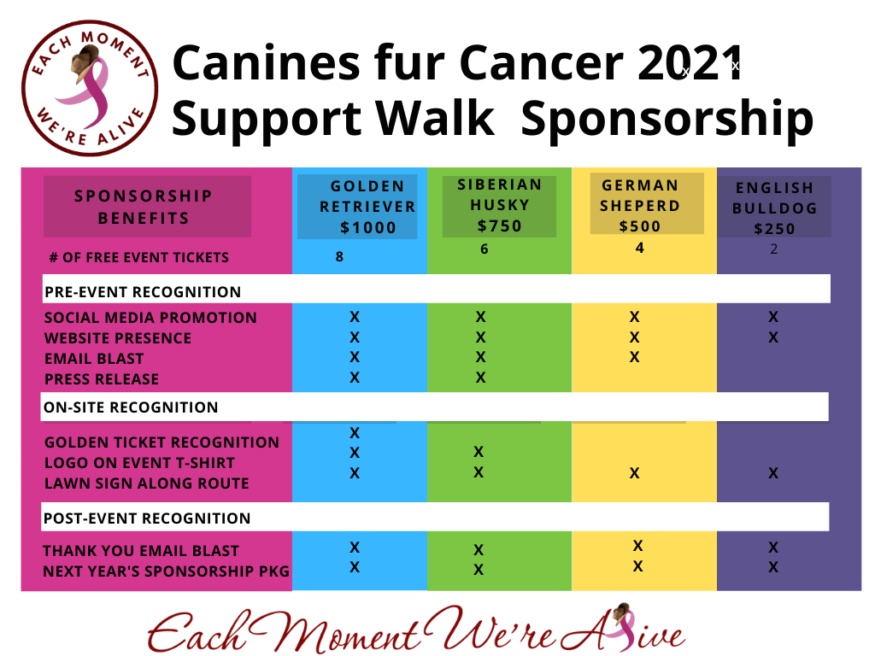

Sponsorship Packages

Email logo to
Cindy@EachMomentWereAlive.org Logo File (EPS preferred, 300 dpi JPG,PDF)
Camera Ready Logo Enclosed

Send payment to
Each Moment We’re Alive, Inc PO Box 651
West Springfield, MA 01089
Or online at EachMomentWereAlive.org

